**EXP NO: 5: 16-BIT ADDITION**  
  
**AIM:**To write an assembly language program to  
implement 16-bit addition using 8085 processor.

**APPARATUS REQUIRED :** GNU sim8085  
  
**ALGORITHM:**  
1)   Start the  
program by loading a register pair with address of 1st number.  
2)     Copy the data to another register pair.  
3)      Load the second number to the first register pair.  
4)      Add the two register pair contents.  
5)       
Store the result in memory locations.  
6)      Terminate the program.  
  
  
**PROGRAM:**  
LHLD 2500  
XCHG  
LHLD 2502  
DAD D  
SHLD 2504  
HLT  
  
**INPUT:**

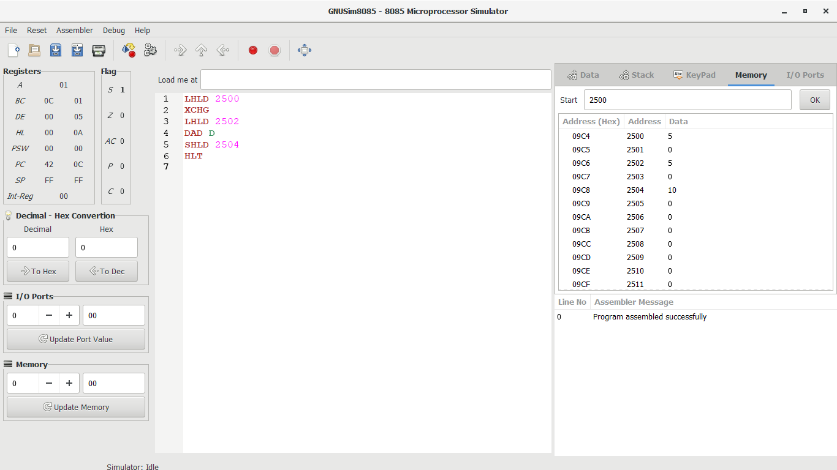

**OUTPUT:**

  
  
  
  
  
  
  
  
  
  
  
**RESULT:**Thus the program was executed successfully using 8085  
processor simulator.